Computer Language Coding Concepts

Command References in a Command Definition in a Diagram
Command references in a command definition have been conceptually explained in the article Command References in a Command Definition.

This article only illustrates how command references in a command definition look in a diagram.

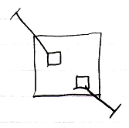

The larger square is a command definition. The smaller square inside them are command references in a command definition. They are actually public command references. This makes the command references parameters of the command definition. The command references have object lines, solid ones, going outside, ending at an access mark. Those object lines are indications of parameter passing, indicating that the command references are so called Reference parameters. Parameter passings are explained in the parameter articles.

See also: Command References in a Command Definition,
Creation Behavior of Command Calls in a Diagram

Author & Copyright: Jan-Joost van Zon Date: August 9, 2008 – August 9, 2008 Location: Oosterhout, The Netherlands Status: Finished

